Experiment Number: 3
MATLAB Analysis of Spectrum Bands, Propagation Loss and Cellular Interference
Aim
To compare a simplified free-space path-loss estimate across representative sub-1 GHz, mid band and mmWave frequencies, and examine how distance and frequency reuse affect received signal and a simple interference measure.
Objectives
By the end of the experiment, students should be able to:
1. Calculate or simulate path loss at representative sub-1 GHz, mid-band and mmWave frequencies.
2. Compare estimated received signal strength as frequency and distance change.
3. Examine how cell separation or frequency reuse changes a simplified interference ratio.
4. Relate the results to coverage and spectrum-use considerations across mobile generations, while stating model limitations.
Requirements
• Computer with MATLAB R2019b or later.
• No RF hardware is required.
Theoretical Background
The free-space path-loss equation in decibels is FSPL = 32.44 + 20log₁₀(f_MHz) + 20log₁₀(d_km), where f is carrier frequency and d is separation. With fixed transmit power and antenna gains, estimated received power is P_r = P_t + G_t + G_r − FSPL. In this idealized equation, doubling distance adds about 6 dB of loss and doubling frequency adds about 6 dB of loss at the same distance.
For a simple reuse illustration, let the desired transmitter be at distance R and six equal-power co-channel interferers be at distance D = √(3N)R, where N is a reuse-cluster size. Under a power-law path-loss exponent n, approximate SIR = (D/R)^n / 6. This idealized first-tier model omits shadowing, fading, sector antennas, unequal loads, terrain, adjacent-channel leakage and real frequency-planning constraints. Because desired and interfering links use the same frequency, frequency-dependent free-space loss cancels in this simplified SIR ratio.

Parameters and Assumptions
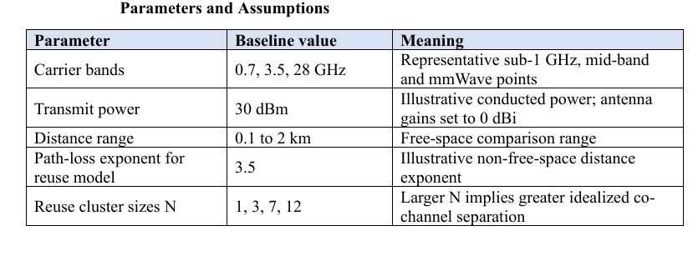

Procedure
1. Run the script and inspect the path-loss and received-power plots.
2. Record the estimated received power at 0.5 km for each frequency.
3. Inspect the reuse-SIR plot and compare the baseline N values.
4. Change transmit power, distance range, path-loss exponent or reuse sizes; rerun and record the effect.
5. Explain why frequency reuse changes the simplified co-channel SIR and why the free space link budget is not a complete coverage prediction.

Output
